Insert your name, centre number and candidate number into the header above.
Save this evidence document as evidence_ followed by your centre number_ candidate number. For example: evidence_ zz999_9999
Screenshots or program listings must be copied into appropriate cells in the following tables.
Examiners must be able to read the contents including any screenshots without the use of a magnifying glass. Answers that are not readable or missing will not be awarded any marks.
Save this evidence document at regular intervals, for example, every 10 minutes.
Question 1
Part 1(a)
{Copy and paste program code listing for question 1(a) here}

Structure Node
Dim Data As Integer
Dim nextNode As Integer
End Structure

Part 1(b)
{Copy and paste program code listing for question 1(b) here}

Sub Main()
Dim linkedlist(9) As Node

linkedlist(0).Data = 1
linkedlist(0).nextNode = 1
linkedlist(1).Data = 5
linkedlist(1).nextNode = 4
linkedlist(2).Data = 6
linkedlist(2).nextNode = 7
linkedlist(3).Data = 7
linkedlist(3).nextNode = -1
linkedlist(4).Data = 2
linkedlist(4).nextNode = 2
linkedlist(5).Data = 0
linkedlist(5).nextNode = 6
linkedlist(6).Data = 0
linkedlist(6).nextNode = 8
linkedlist(7).Data = 56
linkedlist(7).nextNode = 3
linkedlist(8).Data = 0
linkedlist(8).nextNode = 9
linkedlist(9).Data = 0
linkedlist(9).nextNode = -1

Dim startPointer As Integer
Dim emptyList As Integer
End Sub

Part 1(c)(i)
{Copy and paste program code listing for question 1(c)(i) here}

Sub outputNodes(ByVal linkedlist, currentpointer)
While (currentpointer <> -1)
Console.WriteLine(linkedlist(currentpointer).data)
currentpointer = linkedlist(currentpointer).nextNode
End While

End Sub

Part 1(c)(ii)
{Copy and paste the screenshot for question 1(c)(ii) here}

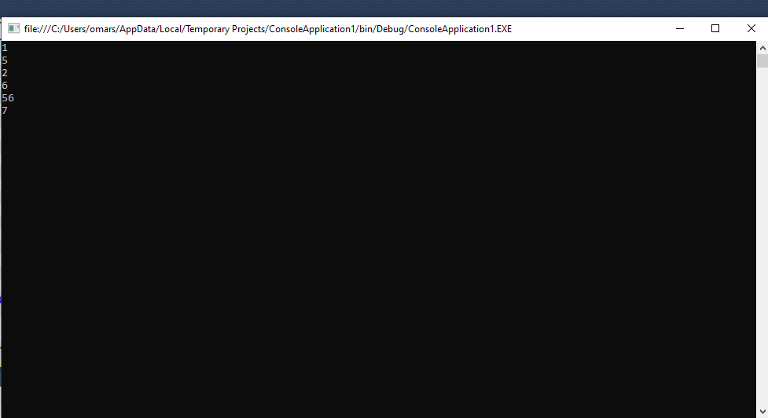

Part 1(d)(i)
{Copy and paste the program code listing for question 1(d)(i) here}

Function addNode(ByRef linkedList() As Node, ByVal currentPointer As Integer, ByRef emptyList As Integer)
Console.WriteLine("Enter the data to add")
Dim dataToAdd As Integer = Console.ReadLine()
Dim previousPointer As Integer = 0
Dim newNode As Node
If emptyList < 0 Or emptyList > 9 Then
Return False
Else
newNode.Data = dataToAdd
newNode.nextNode = -1
linkedList(emptyList) = newNode
previousPointer = 0
While (currentPointer <> -1)
previousPointer = currentPointer
currentPointer = linkedList(currentPointer).nextNode
End While
Dim valueToWrite As Integer = emptyList
linkedList(previousPointer).nextNode = valueToWrite
emptyList = linkedList(emptyList).nextNode
Return True
End If
End Function

Part 1(d)(ii)
{Copy and paste program code listing for question 1(d)(ii) here}

Sub Main()

Dim linkedlist(9) As Node

linkedlist(0).Data = 1
linkedlist(0).nextNode = 1
linkedlist(1).Data = 5
linkedlist(1).nextNode = 4
linkedlist(2).Data = 6
linkedlist(2).nextNode = 7
linkedlist(3).Data = 7
linkedlist(3).nextNode = -1
linkedlist(4).Data = 2
linkedlist(4).nextNode = 2
linkedlist(5).Data = 0
linkedlist(5).nextNode = 6
linkedlist(6).Data = 0
linkedlist(6).nextNode = 8
linkedlist(7).Data = 56
linkedlist(7).nextNode = 3
linkedlist(8).Data = 0
linkedlist(8).nextNode = 9
linkedlist(9).Data = 0
linkedlist(9).nextNode = -1

Dim startPointer As Integer
Dim emptyList As Integer
startPointer = 0
emptyList = 5
outputNodes(linkedlist, startPointer)

Dim returnValue As Boolean
returnValue = addNode(linkedlist, startPointer,emptyList)
If returnValue = True Then
Console.WriteLine("Item successfully added")
Else
Console.WriteLine("Item not added, list full")
End If
outputNodes(linkedlist, startPointer)
Console.ReadLine()

Part 1(d)(iii)
{Copy and paste the screenshot for question 1(d)(iii) here}

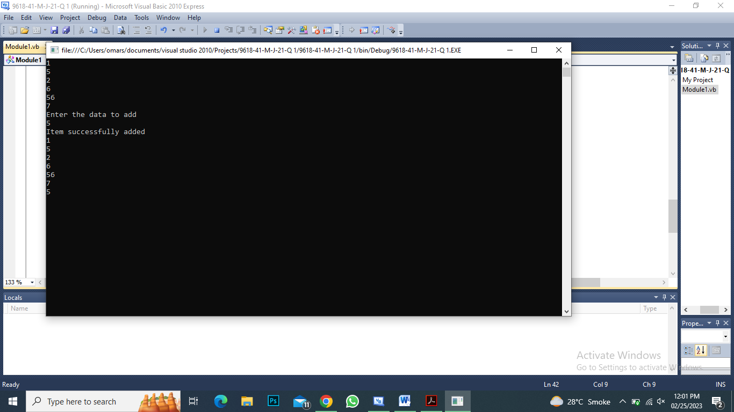

Question 2
Part 2(a)
{Copy and paste program code listing for question 2(a) here}

Part 2(b)(i)
{Copy and paste program code listing for question 2(b)(i) here}

Part 2(b)(ii)
{Copy and paste program code listing for question 2(b)(ii) here}

Part 2(b)(iii)
{Copy and paste the screenshots for question 2(b)(iii) here}

Part 2(c)
{Copy and paste program code listing for question 2(c) here}

Question 3
Part 3(a)
{Copy and paste program code listing for question 3(a) here}

Part 3(b)
{Copy and paste program code listing for question 3(b) here}

Part 3(c)(i)
{Copy and paste program code listing for question 3(c)(i) here}

Part 3(c)(ii)
{Copy and paste program code listing for question 3(c)(ii) here}

Part 3(c)(iii)
{Copy and paste program code listing for question 3(c)(iii) here}

Part 3(c)(iv)
{Copy and paste program code listing for question 3(c)(iv) here}

Part 3(c)(v)
{Copy and paste screenshots of the two tests for question 3(c)(v) here}

